**Updated On-Line Credit Card Portal Instructions:**

You can make an on-line credit card payment through our Core Management System: <https://researchcores.partners.org/pay_with_credit_card>

You will be brought to the below **security screen** where you will enter the requested information and hit **continue**:

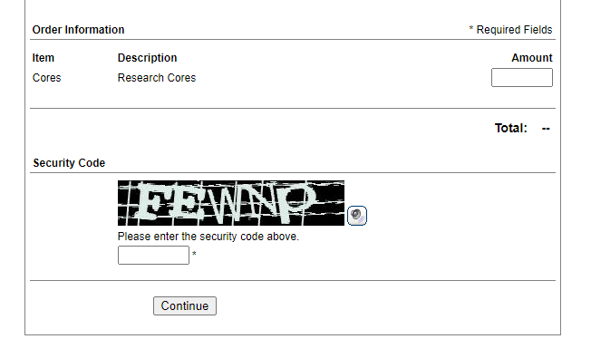

You will then be brought to the next step where you will need to complete all requested information with an asterisk beside them:

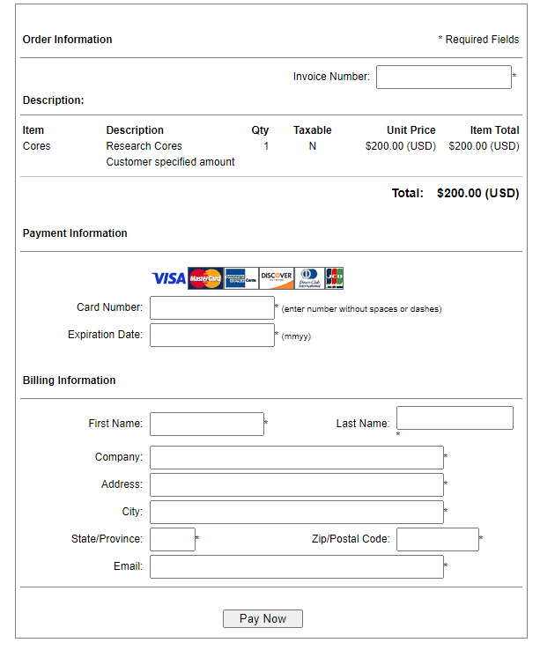

Once you’ve submitted your payment, you should get a copy of your receipt. The bank automatically e-mails the RCFO finance team a notice that a payment has been submitted.