Quick Guide for Zeiss 710 Laser Scanning Confocal
MGH Cancer Center

For any questions or concerns, please contact:
Linda Nieman lnieman@mgh.harvard.edu Office: (617) 643-9684 Cell: (512) 565-8076
Katherine Xu khxu@mgh.harvard.edu Cell: (781) 738-5200

Start Up
Sign In
Turn on equipment in the following order:
- Main System Power (wait until you hear machinery stop moving between each step)
  - Make sure Key on right hand side is in the horizontal position.
  - 1A. Flip MAIN SWITCH to ON position
  - 1B. Flip SYSTEM/PC switch to ON position
    - ***Wait for the Definite Focus module to display OFF*** (this means Definite Focus has successfully started up)
  - 1C. Flip COMPONENTS switch to ON position
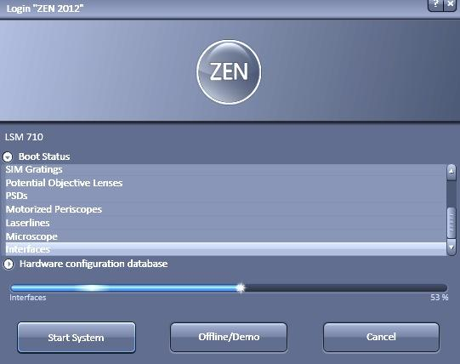
- Argon Laser Black Box Power Supply

  - Turn the key to right (clockwise)
- Argon Laser Remote Controller
  - Flip switch up to ON position
- X-Cite widefield fluorescence light source
  - Flip switch to ON position
  - Write down bulb hours on sign in sheet
  - If all other hardware is on but the X-Cite light off, you can turn it on without restarting the whole system
- Turn on PC
  - Login as LSM USER
  - Wait for ~3 min for RTC to establish connection with computer
- Launch Zen software
  - Double-click black Zen icon on desktop
  - On startup screen appears, click BOOT STATUS drop down and START SYSTEM
    - If screen stalls at 2% or an error about Real Time Controllers pops up: press RTC reset button on box under scope for 5 seconds and wait 30 seconds.
    - If startup fails to continue: close Zen, press RTC reset button, and restart Zen.
    - If that fails: close Zen, power off RTC, and wait 30 seconds. Power on RTC, wait 1-2 minutes, and re-launch Zen
Loading your sample
- If your sample is in a dish or plate, you may need to raise the condenser head so it does not come in contact with your dish/plate. Use the condenser focusing knob (diagram below).
- Push microscope head back. ***Do NOT push on gray HAL100 light box***
- On Touchpad, choose objective. View using 10X first, then progress to higher magnification
- Tap LOAD POSITION (drops down objectives to lowest position)
- Load slide onto stage with coverslip down (orientation for inverted microscope)
- Bring microscope head back into position
- On Touchpad, tap SET WORK POSITION

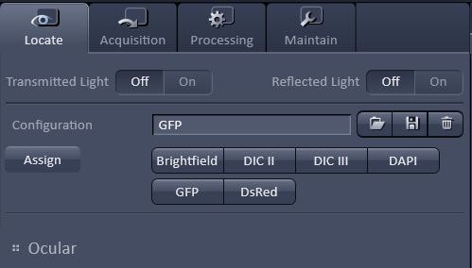
Locating your sample

- In ZEN, go to LOCATE tab

- Choose and click a viewing configuration:
  - BRIGHTFIELD
    - Transmitted light (TL) imaging
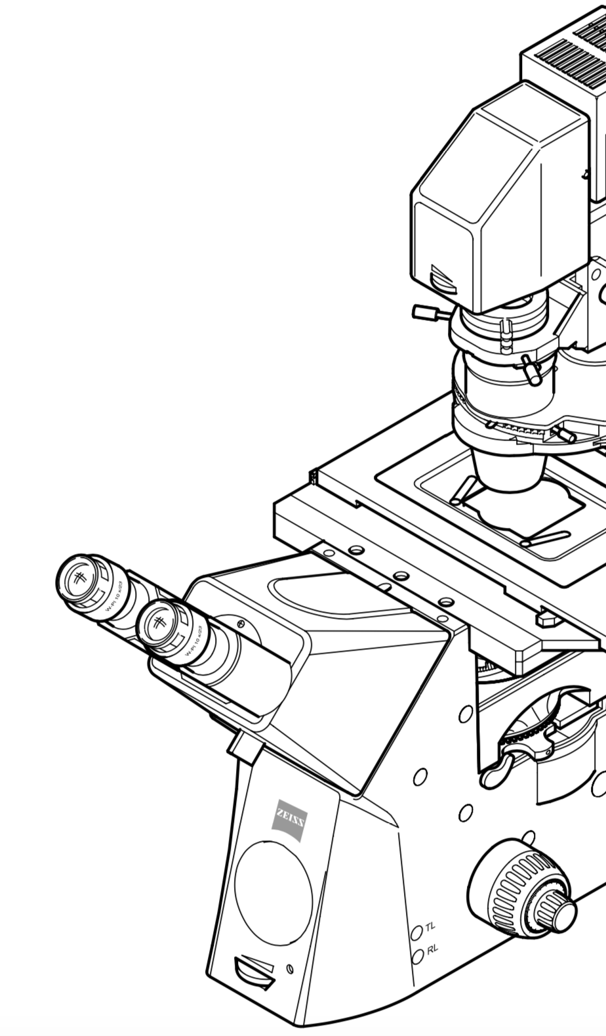
  - Differential Interference Contrast (DIC):
TL brightness dial
Polarizer
    - Swing polarizer into optical path and turn to “0 degrees” position
    - DIC II: use with dry objectives (10x, 20x, 63x dry)
    - DIC III: use with immersion objectives (40x oil, 40x water, 63x oil)
  - Reflected light (RL) imaging (epi-fluorescence):
    - DAPI – blue filter, GFP – green filter, DsRED – red filter

- For epi-fluorescence, adjust RL brightness as needed with black dial on XCite lamp box.
- For brightfield and DIC, adjust TL brightness as needed with dial below eyepiece.

- If doing brightfield or DIC imaging, adjust Kohler illumination for the best image:
  - Close top aperture
Condenser focusing knob
Condenser centering screw
Top aperture stop control
  - Focus condenser head until a focused octagon is formed
  - Center octagon by adjusting condenser centering screws
  - Re-open top aperture
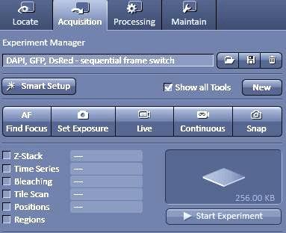
Scan configuration

- Click ACQUISITION tab > under EXPERIMENT MANGER, click SMART SETUP

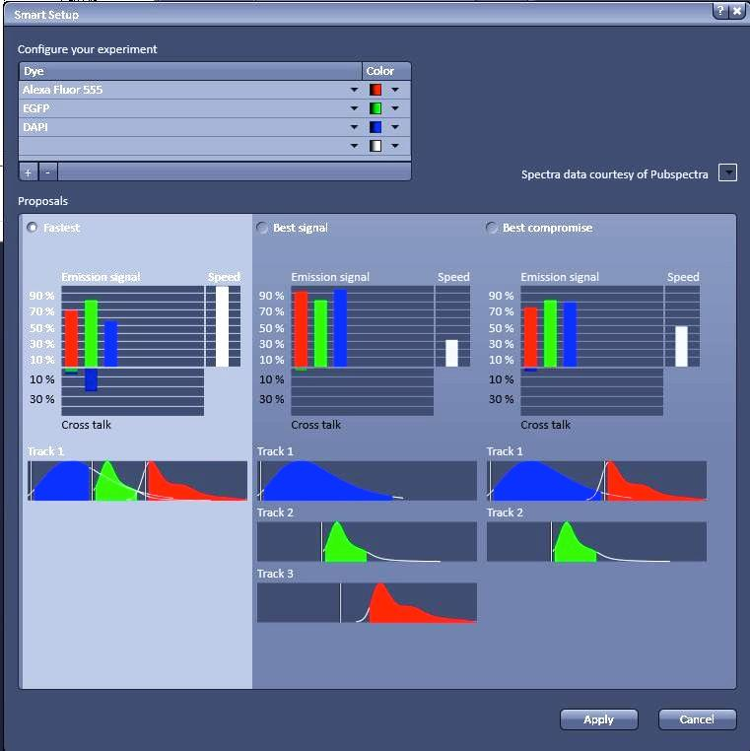
- Under CONFIGURE YOUR EXPERIMENT, choose dyes/fluorophores and corresponding display colors

- Choose imaging option
  - FASTEST:
    - Pro: faster image acquisition
    - Con: potential cross-talk (spectral overlap) between channels.
  - BEST SIGNAL:
    - Pro: Only one detector and one laser are on at once, reducing cross-talk
    - Con: slower image acquisition (each color track imaged separately)
  - BEST COMPROMISE: between speed and spectral separation
  - The tracks show which channels will be simultaneously imaged. The tracks will go in sequence.

- Click APPLY

- To acquire brightfield or DIC images, in LIGHT PATH panel, choose track and highlight channel with shortest wavelength (usually blue), and enable T-PMT

Image capture settings

- In ACQUISITION MODE panel, set the following:
  - SCAN MODE = FRAME
  - FRAME SIZE (i.e. pixel density) = 1024x1024
  - SCAN SPEED = between 7 and 9
    - Faster scanning gives shorter time interval between images, but lower signal-to-noise ratio.
    - Slower scanning gives longer time intervals, but higher signal-to-noise ratio.
  - AVERAGING = 1
    - If you have a dim sample with white noise, you may want to consider averaging at least 4 frames. Averaging frames adds to the total scan time.
  - BIT DEPTH = 12 for publication images
    - Increasing bit depth increases number of gray scale levels (2^{n}). 16 bit for high dynamic range images)
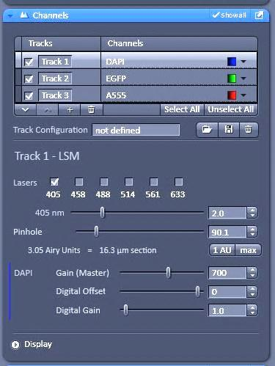

- In CHANNELS panel, set PINHOLE to desired optical section thickness. For best resolution, click 1 AU.
  - There is an inherent tradeoff between spatial resolution and image brightness. If your sample is dim and high resolution is not critical, you may want to set pinhole larger.

Setting detector gains
- Under EXPERIMENT MANAGER, click SET EXPOSURE
  - System will find optimal detector gain setting for each color channel
  - Not setting “exposure” per se, but actually the amplification factor of the detected signal
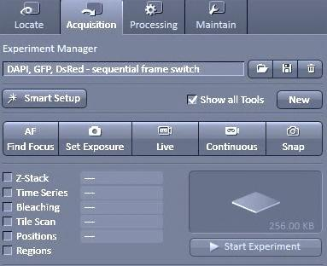

- Click LIVE
  - Live continuously scans sample at low resolution to allow quick adjustments.
  - CONTINUOUS scans sample with image capture settings (high resolution)
  - SNAP scans sample once with image capture settings

- Adjust focus (eyepiece and camera have slightly different focuses)

- Click STOP (Live button switches to stop upon being clicked)

- In CHANNELS panel, click TRACK 1
  - Desired track will be highlighted in light gray. Other tracks can be unchecked (disabled)

- Click LIVE
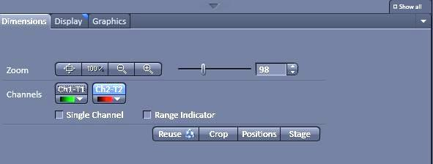

- In DIMENSIONS tab in the image viewing window, enable SINGLE CHANNEL and RANGE INDICATOR and select channel to view
  - Red pixels are saturated
  - Black pixels are underexposed
  - Blue pixels have optimal exposure
***NOTE : Ch = channel, T = track***

- In CHANNELS panel, next to the appropriate channel name, adjust GAIN (MASTER).

  - ***Aim for an image with few red pixels***
    - A good initial value is ~650
    - Maximum value is 1200
  - In DIMENSIONS tab, click next channel in the track and adjust gain

- Click STOP

- In CHANNELS panel, click TRACK 2 and repeat steps 6 through 9 above until all channel gains have been set
Z-Stack

- In EXPERIMENT MANAGER, enable Z-STACK and click LIVE

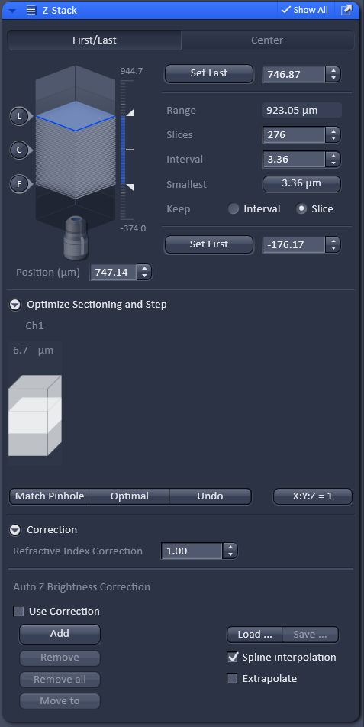
- Go to Z-STACK panel

- Use focus knob to focus (see blue plane in diagram move) on your desired plane closest to objective, then click SET FIRST

- Focus on your desired plane furthest from objective, then click SET LAST

- Click STOP

- Under OPTIMIZE SECTIONING AND STEP, click OPTIMAL and click SMALLEST interval button (based on Nyquist sampling)
  - Alternatively, set number of SLICES

- Under EXPERIMENT MANAGER, click START EXPERIMENT to acquire z-stack

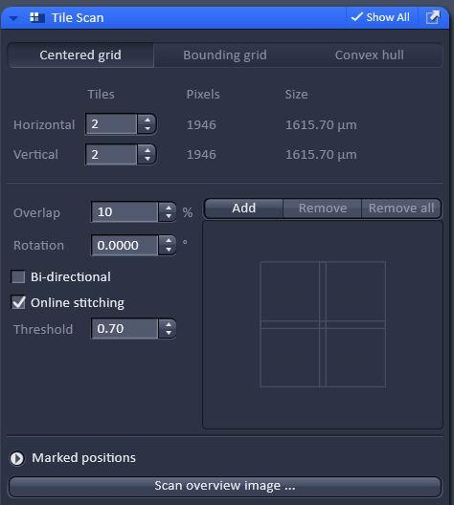
Tile Scan

      - In EXPERIMENT MANAGER, enable TILE SCAN
      - In TILE SCAN panel, click CENTERED GRID tab
      - Modify number of tiles
      - Choose overlap percentage (10%) and enable ONLINE STITCHING
      - Click START EXPERIMENT to acquire tile scan
      - After a tile scan, speed may auto change to 10, so remember to set it back to your desired speed before your next scan.
***The stitched image is saved as a single file***

Crop

- In DIMENSIONS tab, click CROP

- Adjust red box around desired scan area

- Click LIVE then STOP to view cropped scan area

- Click SCAN to acquire cropped image
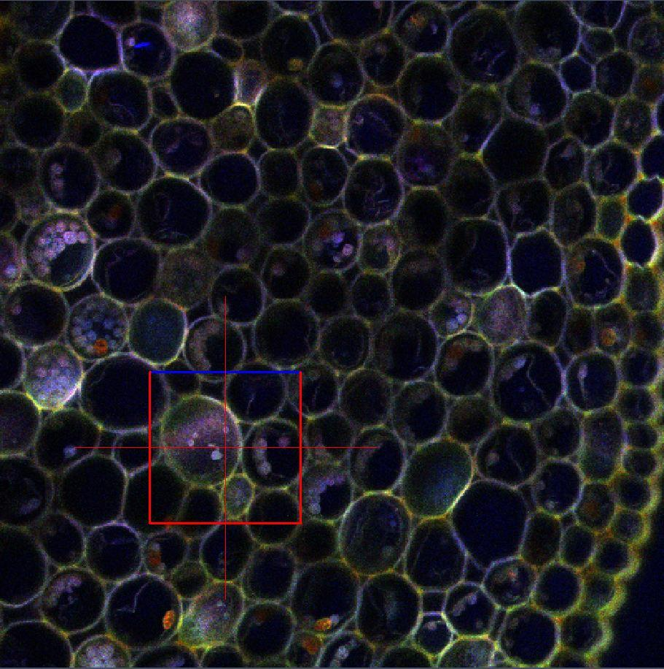

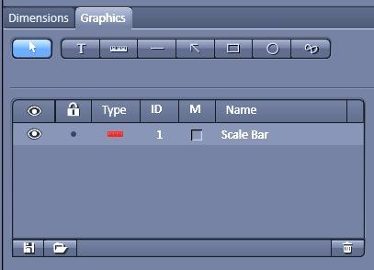
Graphics / Overlays
In GRAPHICS tab, add in:
  - Text
  - Scale bar
  - Lines
  - Arrows
  - Boxes
  - Circles
  - Free draw

Saving your images
- In IMAGES AND DOCUMENTS panel in top right of screen, click DISK icon
- Save to local D drive: Data / LAB PI NAME / YOUR NAME. ***Please do not store data permanently on computer***. Data folders are periodically deleted.
- Images are saved as .czi files, which can be opened in ZEN LITE (free version of ZEN for Windows only) or FIJI / IMAGEJ (free download for Mac and Windows).
- To export images as .tif files, go to FILE in top toolbar, click EXPORT
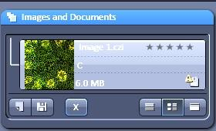

Shutting Down
Sign out and clean work area with 70% ethanol. Clean any immersion objectives used with LENS PAPER, using a clean region and swiping once with each wipe.
*** DO NOT USE KIMWIPES ON OBJECTIVE LENS! ***

If you are the last user of the day, completely shut down the system and put the dust cover over the microscope (with slit on back).
Turn off equipment in following order:
6. Close Zen software
5. Shut down PC
4. Turn off X-Cite light source
3. Argon Laser Remote controller: Flip switch down to OFF Position
2. Argon Laser Black Box Power Supply: Turn key to left (counter-clockwise)
1. Main system power:
1C. Flip COMPONENTS switch to OFF position
1B. Flip SYSTEM / PC switch to OFF position
*** WAIT 5 MINUTES TO LET LASER COOL *** (you will hear fan turn off when laser is cool enough)
1A. Flip MAIN SWITCH to OFF position

Image viewing software
ZEN Lite (Windows only)
ZEN Lite is your free copy of ZEN imaging software. Use ZEN Lite to try key features of the ZEN core package or install it as a viewer for CZI files. ZEN Lite can:
- Control Axiocam microscope cameras
- Create microscope images and simple video sequences
- Measure distances interactively
- Manage images/videos and export them into various formats
- View meta information relating to CZI image files
- Use simple report functions
Expand ZEN Lite with selected modules: create impressive multichannel and time lapse images or use extended measurement functions.

Download: http://www.zeiss.com/microscopy/en_us/products/microscope-software/zen-lite.html

FIJI (ImageJ)
ImageJ is an open source Java image processing program inspired by NIH Image. It runs on any computer with a Java 1.8 or later virtual machine. Downloadable distributions are available for Windows, Mac OS X, and Linux. ImageJ has a strong, established user base, with thousands of plugins and macros for performing a wide variety of tasks.

Download: https://imagej.net/Fiji/Downloads

