TBC User Guidelines
Document Overview
This document is intended to provide guidelines for all users to create an account, add funds, and place an order on the Partners Core Management system and submit samples to CAMD TBC.
Table of Contents
Step 1 | Creating and Logging into an Account 1
a) For New Users 1
b) For Current Users 1
Step 2 | Adding Fund(s) Information 1
Adding a New Fund 1
a) MGB users 2
b) DFCI users 2
c) External Non-MGB users 3
Step 3 | Notification Preferences 4
Adding additional email recipients to your user account. 4
Step 4 | Creating a Service Request 5
Next Steps 8
References 9

Step 1 | Creating and Logging into an Account
- Visit https://researchcores.partners.org/camd/about
  - For New Users, create an account by choosing Signup in the upper right corner; once the account is established, follow the Login instructions.
  - For Current Users, login to your account by choosing Login to either place a new order or update an existing service request.
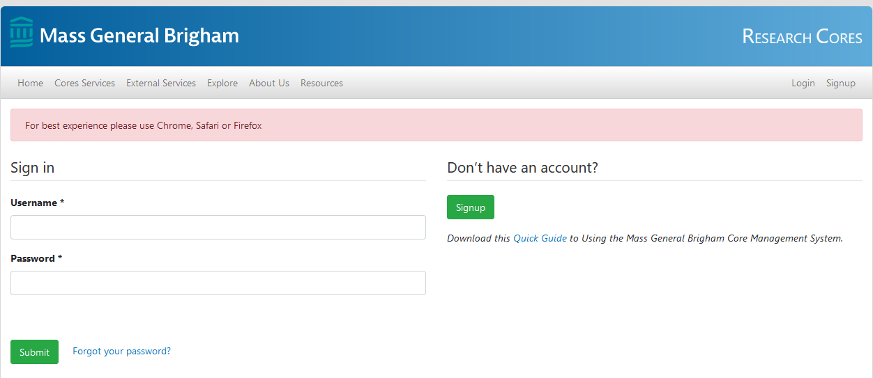

Step 2 | Adding Fund(s) Information

Adding a New Fund
- Click Funds under User. If you are unable to view the page below, please use this link: https://researchcores.partners.org/my/funds
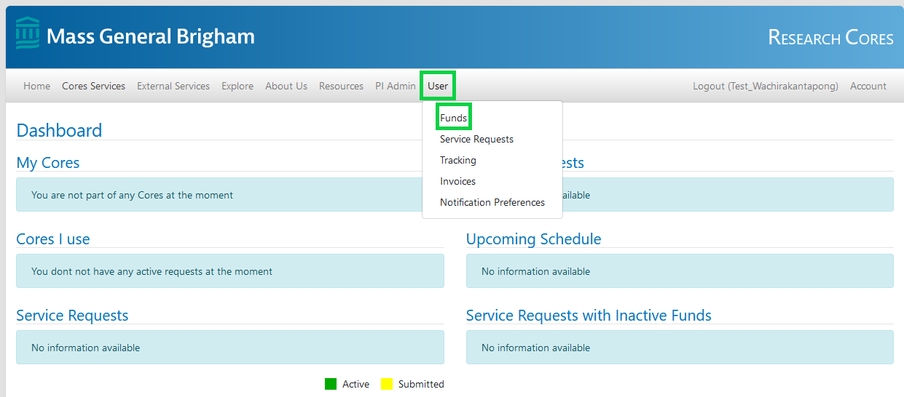

- Click the green New Fund button in the upper right.
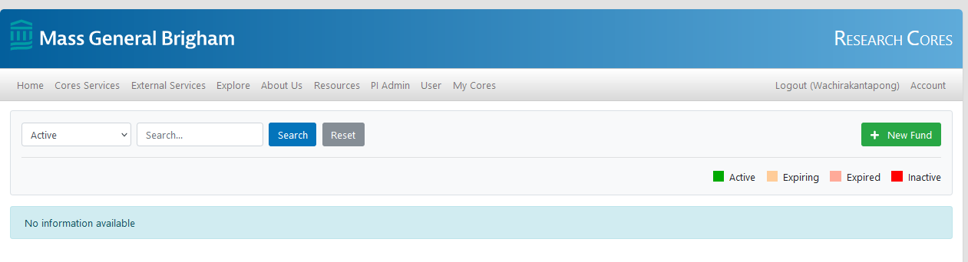
- Fill in the Funding information.
  - MGB users, under Payment Type please select MGB and provide a 6-digit Partners Fund Number, Business Unit, Project Title, PI Name, Start Date, and End Date (please select a date in the future that exceeds the length of the study by at least 3 months). Click Assign Fund.
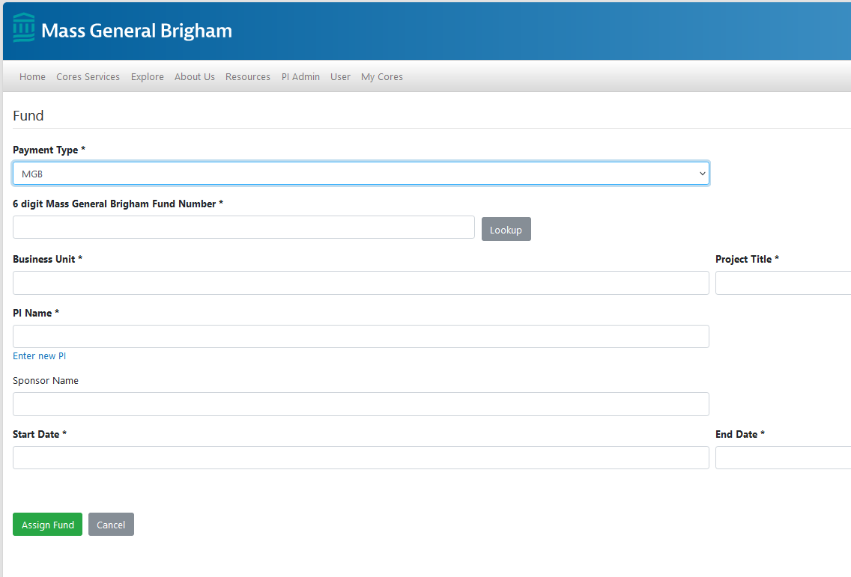
  - DFCI users, please note that we are unable to accept DFCI Internal Cost Center numbers since we cannot direct charge for services. The preferred payment method is a Purchase Order (PO), which must be requested from your grant or financial administrator; if you need a quote in order to request the PO, please contact us at BWHCAMDResearchCore@bwh.harvard.edu. We accept the following four payment options:
      - For Purchase Order (PO), under Payment Type please select Non-MGB, check PO Number and fill in the information. The PO# must start with three zeros (000#######) or the payment will not be drawn properly.
      - For Check, under Payment Type please select Non-MGB, Check and click here for instructions under Next Steps, 4b regarding how to remit payment.
      - For Credit card, under Payment Type please select Non-MGB, check Credit Card and click here for instructions under Next Steps, 4b regarding how to remit payment.
      - If you are a DFCI user affiliated with an MGB funding source, under Payment Type please select MGB and provide a 6-digit Partners Fund Number and Business Unit. Click here for instructions.
Once the funding information is completed, enter the Project Title, PI Name, Start Date, and End Date (please select a date in the future that exceeds the length of the study by at least 3 months). Click Assign Fund.
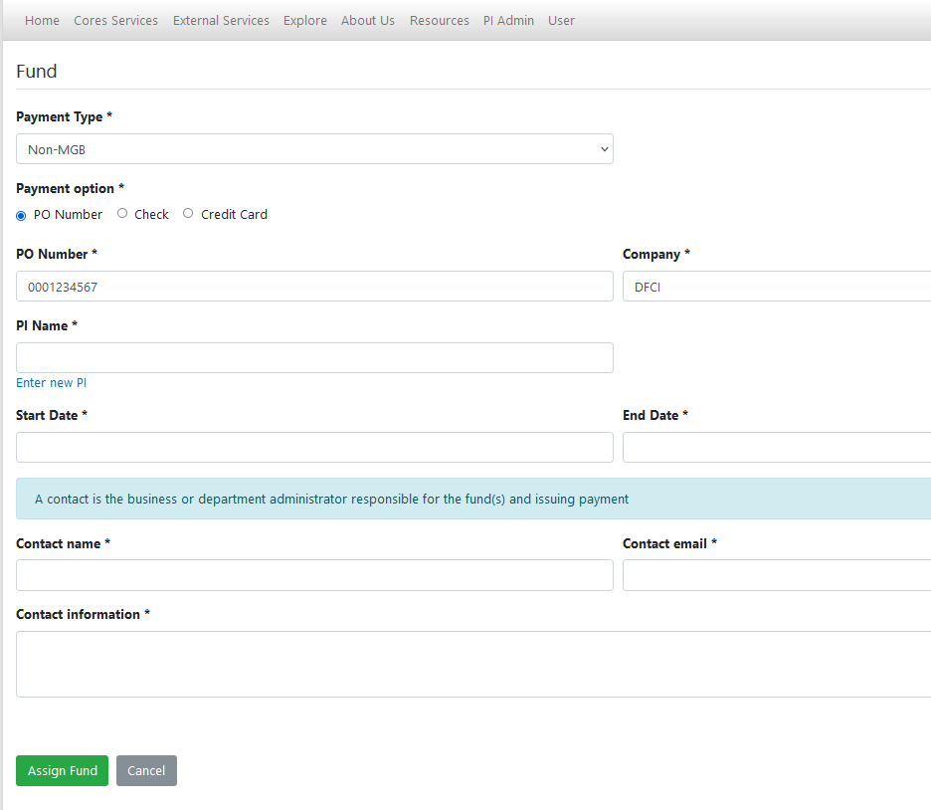
  - External Non-MGB users, the preferred payment method is a Purchase Order (PO); please contact us at BWHCAMDResearchCore@bwh.harvard.edu if you need a quote in order to request the PO. We accept the following three payment options:
      - For Purchase Order (PO), under Payment Type, please select Non-MGB, select PO Number, and fill in the information.
      - For Check, under Payment Type please select Non-MGB, Check and click here for instructions under Next Steps, 4b regarding how to remit payment.
      - For Credit card, under Payment Type please select Non-MGB, check Credit Card and click here for instructions under Next Steps, 4b regarding how to remit payment.
Once the funding information is completed, enter the Project Title, PI Name, Start Date, and End Date (please select a date in the future that exceeds the length of the study by at least 3 months). Click Assign Fund.
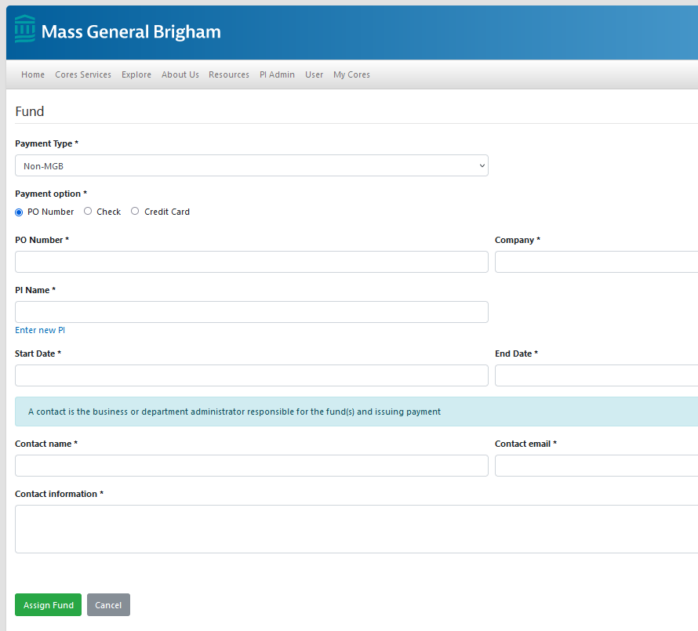
For more information about funding guidelines, please visit https://researchcores.partners.org/forms_resources.

Step 3 | Notification Preferences

Adding additional email recipients to your user account.
- Visit https://researchcores.partners.org/my/notification_preference
- Provide an alternative email if you have more than one account or have colleagues that must receive notifications regarding service requests (separate multiple addresses by semicolon).
- Provide either a Finance or Grant Administrator email address to facilitate payment of invoices.
  - For DFCI users paying with a PO, please include the email address GHXODAP.DFCI@na.firstsource.com under Invoice and Invoice Reminder.
- Ensure to select Both under Send To.
- Click Update.
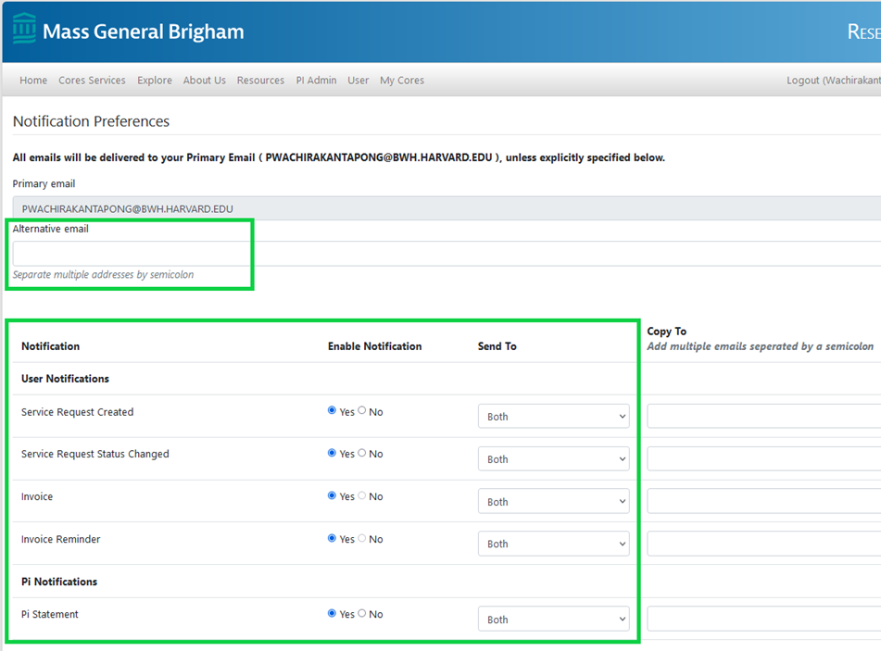
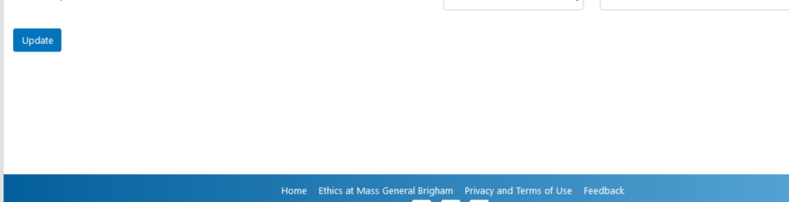

Step 4 | Creating a Service Request
- Click Services in the upper left or visit https://researchcores.partners.org/camd/services
- Check any services you would like to place an order and click the blue button in the upper left, Order Services.
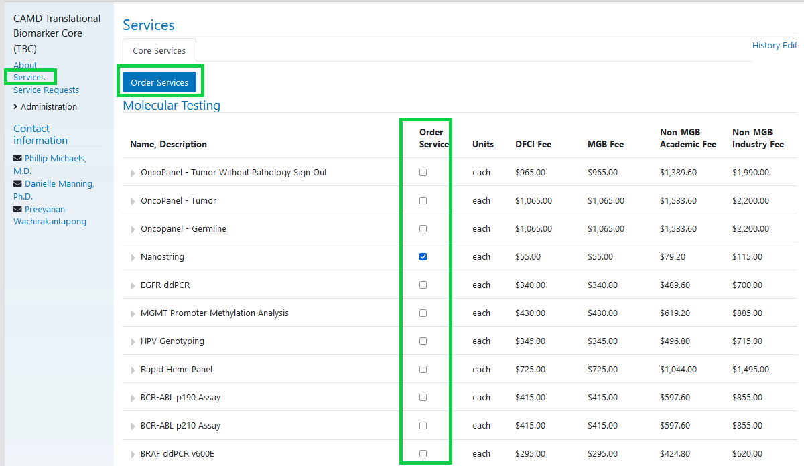
- Provide the Project name under Service Request.
- Enter the total number of units for the project. If the total number of units is not finalized when the requisition is opened, please add an estimated unit for each service you selected.
  - For Single Projects/Studies, add the number of units/samples for each service.
  - For Longitudinal Studies, please provide the number of expected units for each service.
PLEASE NOTE: OncoPanel-without Pathology sign-out is only permitted if a BWH Pathology faculty member will sign out the cases; if selected, please provide your Collaborating Pathologist’s Name in the Detailed Project Description below.
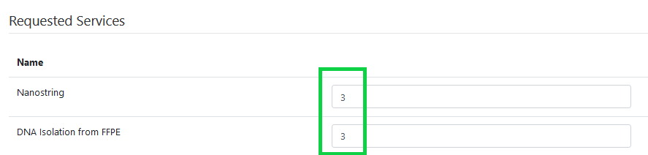
- Fill in the Detailed Project Description and Expected Findings.
  - Detailed Project Information must include:
    - The study PI information (Name, Last Name) or the study ID.
    - A brief description of the project, including project rationale and goals.
    - If the sample type is Formalin-Fixed Paraffin-Embedded (FFPE) and an H&E will not be submitted with the slides, please note that we should scrape all tissue.
  - Expected findings may be indicated for diagnostic testing, if applicable (i.e., genes of interest for OncoPanel or RHP).
- Select Yes if the project is ongoing/longitudinal. Select No for a single project.
- Provide the specimen information. PLEASE NOTE: We require 2 matching identifiers on the physical sample(s) and the submission form.
  - Physical Sample Requirements:
    - The provided Sample ID must match one ID on the material submitted and the other ID must match an additional identifier. For FFPE samples, both IDs on H&E and USS must match.
    - Acceptable sample identifiers include subject number, block number (FFPE), surgical case number, SHL accession, DOB or YOB, and initials.
  - Submission Form Requirements:
    - Acceptable sample information documentation:
      - CAMD TBC Service Request – complete the Sample Information section on the TBC website.
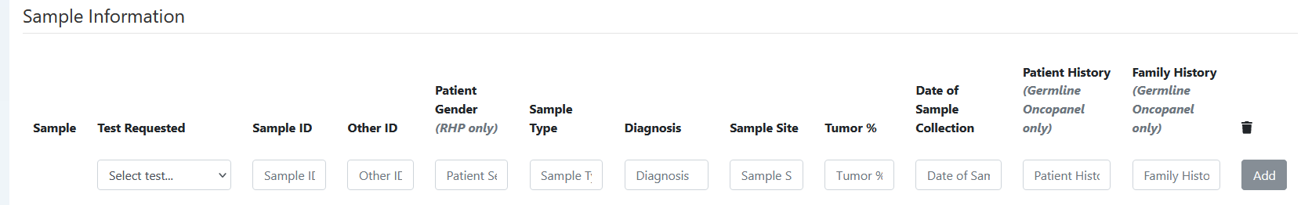
      - Sample Manifest Excel File – in lieu of typing into the website, complete a sample manifest and upload it to the Service Request in the Documents section.
      - Custom Submission Form – for ongoing/longitudinal studies, TBC can assist in creating a custom requisition per project. Contact BWHCAMDResearchCore@bwh.harvard.edu for details.
    - The identifier information must be identical between the form and samples; receipt of mismatched and/or incomplete sample information will delay processing.
- Provide IRB# if required. If unknown or not required, fill in N/A under Content Attestation. Select Yes or No under Patient consent received. Provide your password.
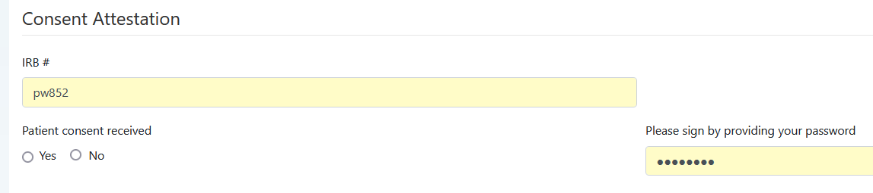
- Provide Contact name and Contact email address under Contact Information and Click Create.

Next Steps
- Once you click Create, the unique identification number (CAMD-#####) will be assigned to your project.
- Please email us at BWHCAMDResearchCore@bwh.harvard.edu; include the date and time you would like to stop by if you are a walk-in user or send a shipping notification with tracking number for all sample shipments.
  - Be sure to include the PI name or Study ID and the CAMD-ID number (CAMD-#####) in the subject line of the email for all correspondence.
  - Include a printed copy of the completed Service Request, Sample Manifest, or Custom Sample Submission Form (for ongoing/longitudinal studies) with each drop-off or shipment to the appropriate address below.
    - Walk-in Address | Monday - Friday 9:30am-4:00pm
ATTN: CAMD TBC Research Core (CAMD-#####)
70 Francis Street
BWH Shapiro building
CAMD Specimen Receiving Window, 5th floor, N Elevator (follow the arrow signs as you exit the elevator)
    - Shipping Address | Monday - Friday 9:30am-4:00pm
ATTN: CAMD TBC Research Core (CAMD-#####)
Brigham and Women's Hospital
Center for Advanced Molecular Diagnostics, SH-5032
75 Francis Street, Boston, MA 02115
PLEASE NOTE: We are unable to accept weekend deliveries, including holidays. Please only ship/drop off the materials with guaranteed delivery of Monday-Friday before 4:00pm. For MGB holidays, please click here.
- Reports
  - For OncoPanel, reports will be delivered via OneDrive (approximately 4-8 weeks from the time we receive the sample). One of our TBC colleagues will reach out to you with a link to your project folder.
  - For all other assays, reports will be delivered to the email address(es) provided via PowerPath.
- Billing
  - Once the project is completed, the invoice will be auto generated and sent from our system on the 7th of the following month to the email addresses provided.
  - To pay by credit card, visit https://researchcores.partners.org/forms_resources and click Pay with Credit Card then complete the information.
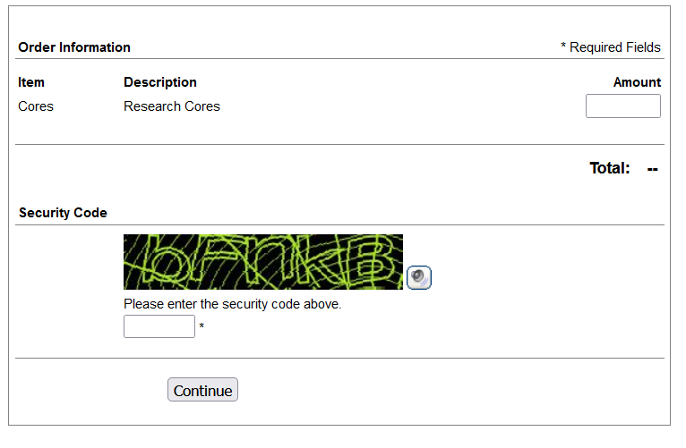

References

